|  |  |
| --- | --- |
| **Date** | 3 August 2025 |
| **Team ID** | LTVIP2025TMID30830 |
| **Project name** | Lease management |
| **Maximum Marks** |  |

**Technical architecture Overview:**

The Lease Management System is built entirely on the **Salesforce Platform**, utilizing both **declarative** (point-and-click) and **programmatic** (code-based) components to automate lease operations, enforce business rules, and enable real-time data tracking.

**Technical stack componts :**

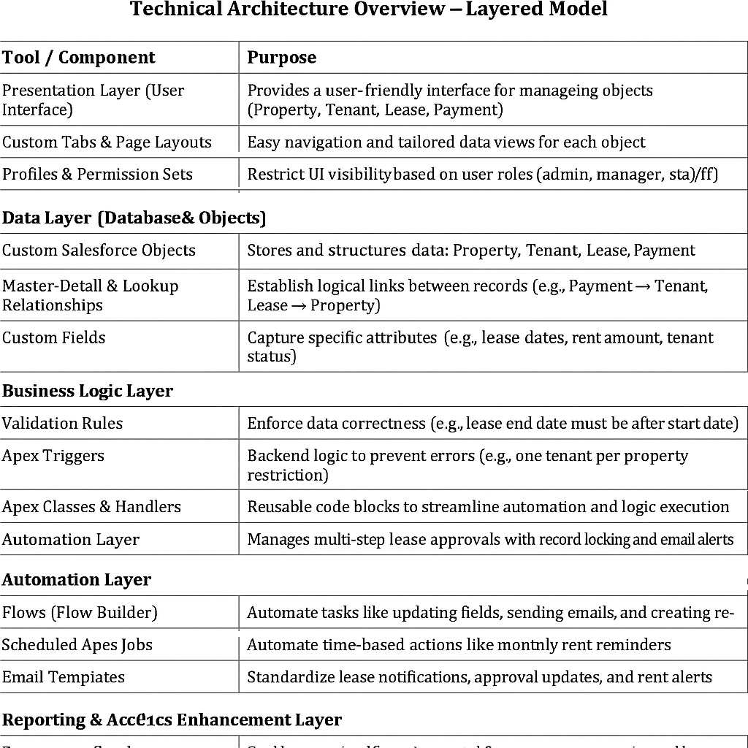



:

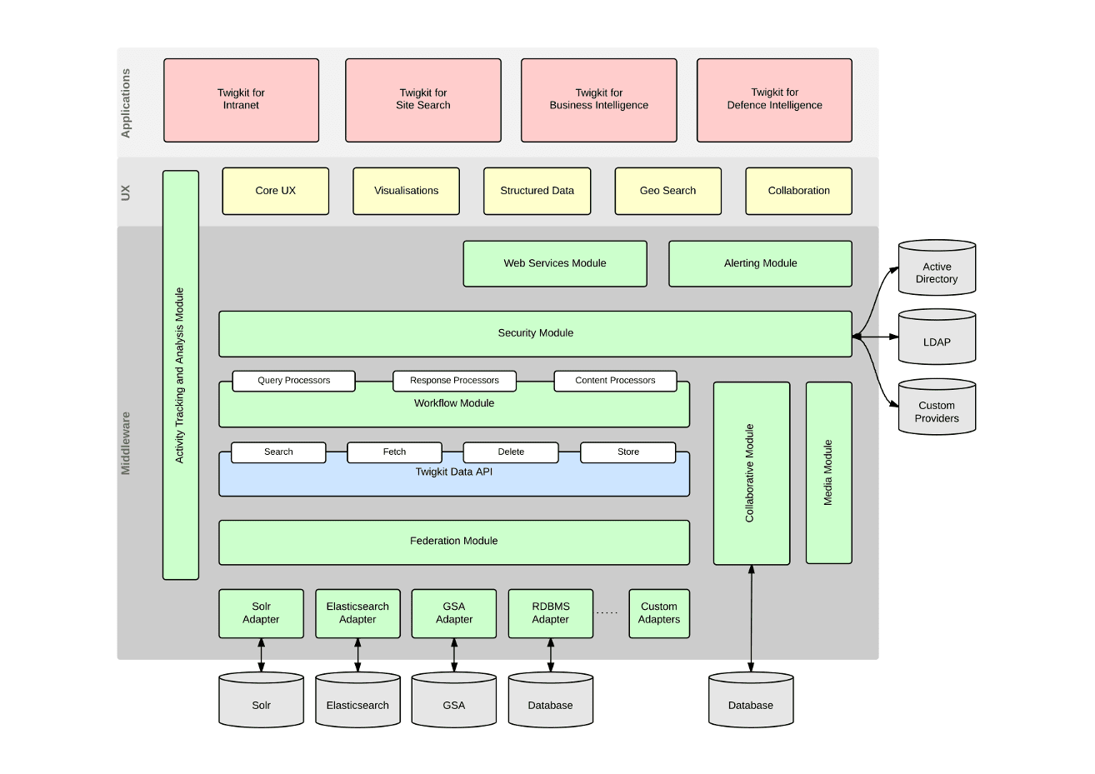

**🧾 Conclusion**

The Lease Management System successfully streamlines real estate lease workflows through a centralized, automated Salesforce Lightning application. It improves accuracy in data entry, enhances communication via email automation, and supports complex business logic with validation rules and Apex code**.**